Housing Market, Money, and the Effect of Monetary Policy in UK

Table of Contents

Abstract 3

Chapter 1 – Introduction 4

1.1 General Landscape 4

Chapter 2 – Data Description & Analysis 6

2.1 Sales 6

2.2 Indexes 7

Chapter 3 – Model Estimation 8

3.1 OLS (Ordinary Least Square) Model 8

3.2 Time Series Model 8

3.3 Model Results 9

3.4 Impulse Response Function 9

Chapter 4 – Considerations and Implications 10

4.1 Brexit 10

4.2 Covid 10

4.3 Monetary Policies 11

Chapter 5 – Limitations & Conclusions 13

5.1 Limitations of our study & Recommendations for future Research 13

5.2 Conclusions 13

Appendix 14

Vector Error Correction Equation for variables 22

References 27

# **Abstract**

When people buy or sell houses, either to live in or as an investment, we refer to this as the housing market. A house is the most valuable thing many people will ever own. The house market is one of the biggest in any developed country and therefore one of the most impactful.

Previous studies had been conducted using the different models and variables, however, to our knowledge at the moment, none has considered the best theoretical approach to the inherent structure of the data. In fact, most models we based on our research used mostly VAR models. The purpose of this study is to investigate key aspects of the UK house market. Our main objective is to understand the relationship between the house prices and the interest rate set by the monetary policy. This is done using quarterly data from 1975 to 2020 and developing a time series Vector Error Correction Model. This approach allows us to distinguish between statistical correlation and economic causation.

From our final model, we find that the effect of a GDP on house prices is large, and the monetary policy shock is existent but not so relevant in the short-medium period while it increases in the long run but not as much as we would have expected. Shocks to the CPI and the interest rate are in turn found to have significant effects on house prices.

Due to the large confidence bands of the impulse responses this result is, however, in general not statistically significant. Further research should be conducted in order to better understand the effect of a market targeting monetary policy used to mitigate the economic uncertainty and unbalances.

# **Chapter 1 – Introduction**

In this section, we will describe briefly the UK housing market.

## **General Landscape**

The total value of the British property market now stands at £7.93 trillion, having fallen by 0.37 per cent (£29 billion) during the first quarter of 2017 (Zoopla).

In Britain, two thirds of households own the house they live in; half of these are still paying off their mortgage. The remaining third of households are renters, split fairly equally between private and social renting.

The housing market is closely linked to consumer spending. When house prices go up, homeowners become better off and feel more confident. Some people will borrow more against the value of their home, either to spend on goods and services, renovate their house, supplement their pension, or pay off other debt. When house prices go down, homeowners risk that their house will be worth less than their outstanding mortgage.  People are therefore more likely to cut down on spending and hold off from making personal investments. Mortgages are the greatest source of debt for households in the UK. If many people take out large loans compared to their income or the value of their house, this can put the banking system at risk in an economic downturn. A rise in house prices is associated to a higher economic growth, while a drop is linked to lower economic growth.

In particular, in recent years many industrialised countries have experienced extraordinarily strong rates of money and credit growth accompanied by strong increases in house prices. This observation raises a number of questions which are potentially of importance for monetary and regulatory policies: Does the observed coincidence between house prices and monetary variables reflect merely the effects of a common driving force, such as monetary policy or the economic cycle, or does it reflect a direct link between the two variables? If there is a direct link, does it run from house prices to monetary variables or from monetary variables to house prices, or in both directions? Do fluctuations in house prices and monetary variables have repercussions on the macroeconomy, i.e. for the development of real GDP and consumer prices? And finally, what is the relevant monetary variable in this context, money or credit, or both?

There is also a collateral effect of house prices emanating from the fact that houses are commonly used as collateral for loans because they are immobile and can, therefore, not easily be put out of a creditor’s reach. As a consequence, higher house prices not only induce homeowners to spend and borrow more, but also enable them to do so by enhancing their borrowing capacity.

In reality, the house market size and effect is difficult to capture in its entirety because not all the parts that form it contribute to the GDP directly.

There are also more fundamental reasons why house prices may change. For instance, demand for housing may rise if the population is increasing or there are more single-person households. Growing demand usually means higher house prices. Prices will also tend to be higher if fewer houses are built, reducing the supply of housing. The fewer houses that are built, the more people will need to compete by increasing the amount of money they are willing to spend to buy a house

There have also been times when house prices have increased a lot just because people think prices will continue to rise. This is called a housing market bubble. Bubbles are always followed by housing market crashes when house prices fall sharply.

These theoretical considerations suggest that there are probably good reasons to believe that there exists a multidirectional link between money, credit, house prices and the wider economy. However, while these theoretical considerations give us some tentative indications, they do obviously not allow any definite conclusions. In the absence of a theoretical model integrating all the potential interlinkages between house prices and the macroeconomy, the issue ultimately has to be addressed empirically.

The paper is organized as follows: In section 2, we will investigate each variable searching for preliminary information and understanding the relationship between the variables. In section 3, we will present the first attempt to build a model based on past literature but considering new factors and using recent data. In section 4, we will explain considerations and implications of our study as well as its limitations. In section5, we will state our conclusions along with policy concerns emerging from our study.

# **Chapter 2 – Data Description & Analysis**

In this section, we will present what data has been gathered as well as their main description. We have collected data in the form of Time Series at UK level from Federal Reserve Bank of St. Louis, Bank of England and Nationwide quarterly from year 1975 to 2020.

## **2.1 Sales**

The variables collected are following:

* Real GDP
* Unemployment Rate
* Fixed Mortgage Rate
* Euro Interbank Rate
* Interbank Rate (3 months)
* Population

We considered different interest rates. The Fixed Mortgage Rate describes the interest rate of a fully amortizing mortgage loan from banks which remains the same throughout the term of the loan. The Euro Interbank Rate which describes the interest rate at which the banks lend and borrow money from other banks in the euro zone. Finally, the interbank rate describes the interest rate at which the banks lend and borrow money from other banks in UK (dealing with quarterly data, we opted for 3-months period rate).

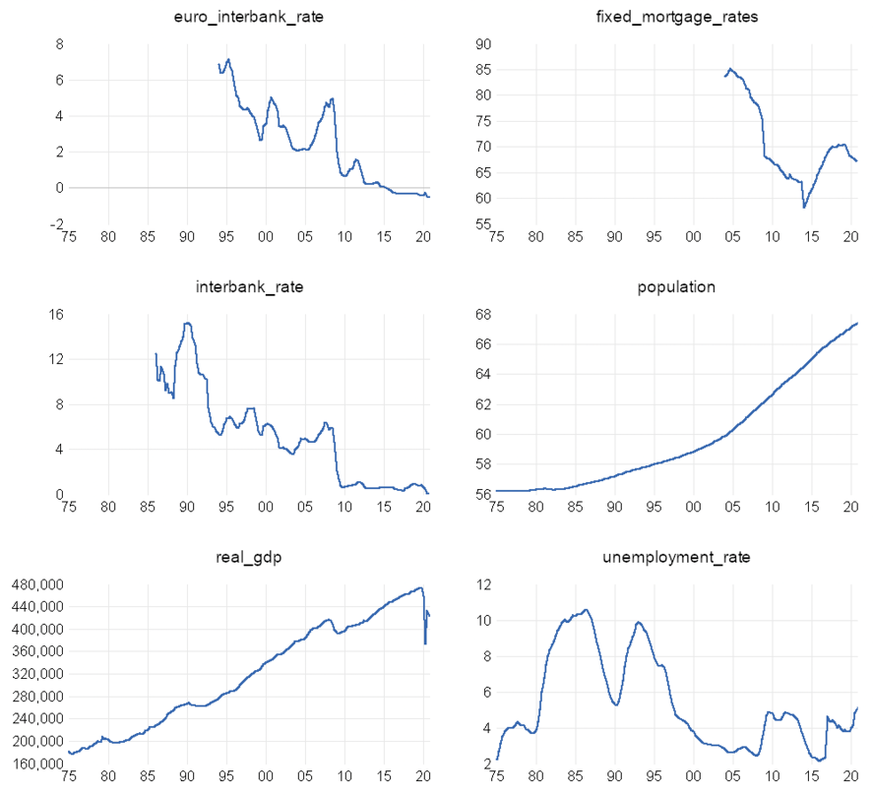

G1. Line plots of variables

## **2.2 Indexes**

We collected the data as:

* House Price Index
* Economic Uncertainty Policy Index (EPUI)
* CPI (Consumer Price Index)

Nationwide is one of UK’s largest mortgage providers and has the longest unbroken run of house price data from 1952 on quarterly basis. Even though actual data would be better, the indexes serve as a good proxy as you can see from the graph, it is the case of House Price Index which capture very well the instability of the economy.

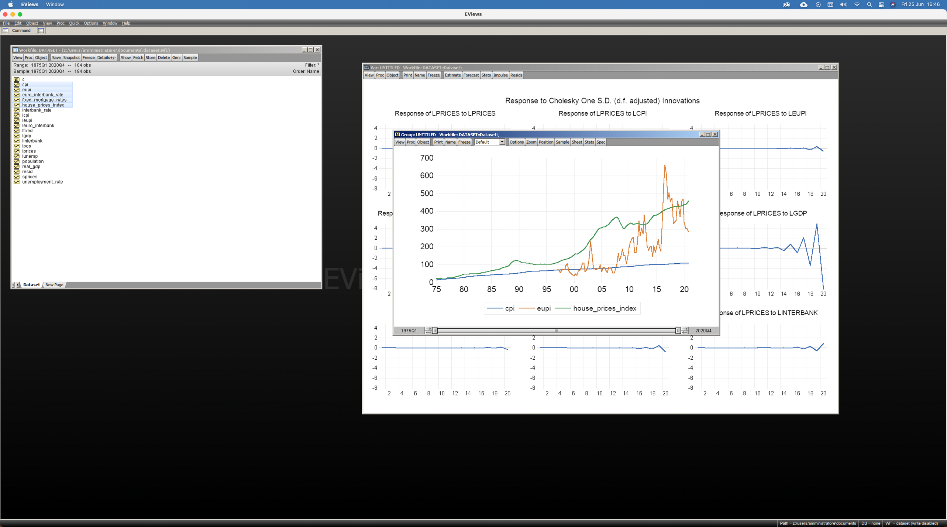

G2. Indexes Graph

The Consumer Price Index (CPI) measures the average change in prices over time that consumers pay for a basket of goods and services. It is the most widely used measure of inflation and, by proxy, of the effectiveness of the government’s economic policy.

The Economic Policy Uncertainty Index (EPUI) measures the policy-related economic uncertainty. It is based on three components. One component quantifies newspaper coverage of policy-related economic uncertainty. A second component reflects the number of federal tax code provisions set to expire in future years. The third component uses disagreement among economic forecasters as a proxy for uncertainty.

# **Chapter 3 – Model Estimation**

In this section, we will expose our methodology, the models we considered and their results.

## **3.1 OLS (Ordinary Least Square) Model**

In this first step, we are interested in estimating the causality of a set of variables on the house price index. We also want to forecast it accurately. In order to do so we need to build a model based on past data following the below formula:

$$y_{t}=γx_{t-1}+ε$$

where $y_{t}$ is the raw data of house price index on time t, $x_{t-1}$ is the combination of raw data of predictors on time t-1 and $γ$ is the coefficient for each random variable.

The model equation is as follows:

$$house_price_index=β_{o}+β_{1}(real_gdp)+ β_{2}(interbank_rate)+β_{3}(euro_interbank_rate)+β_{4}(fixed_mortgage_rate)+β_{5}(unemployment_rate)+β_{6}(cpi)+β_{7}(population)+β_{8}\left(epui\right)$$

Despite fitting Ordinary Least Squares model, it is necessary to fit the time series model since one of the assumptions underlying ordinary least squares (OLS) model is that the error terms are independent. This assumption is easily violated for time series data such as this one since it has a clear pattern in residuals over time. Therefore, we found that the error terms have autocorrelation.

## **3.2 Time Series Model**

First thing first, we performed series of test for unit roots (stationarity) through Augmented Dickey Fuller Test. We find out that all the variables had unit roots). Fortunately, each one of them was resolved using first difference technique, expect for population for which we had to use two differences. The, we adopted the so called log-log transformation for both dependent and independent variables. Log-log model allows us to normalise the data and stabilize the variance (not all of them resulted in normalized variables, for example house_price_index). Dealing with macroeconomics policies such as monetary, it would be more realistic to assume an effect on prices extended over time. To capture this assumption, we applied a multiple test to choose the correct number of lags for the model. Following the results, the optimal number of lags was 4 or 5 considering the AIC (Akaike Information Criteria) as it is often used to build this type of models. We found out through Breusch Godfrey test that autocorrelation is persistent in our data. The last thing is to check the cointegration. We have performed Johansen Cointegration Test and found that the rank is at most 8. The cointegration test is performed to understand the long run relationship between the variables. Based on the results we decided best theoretical model for our analysis is Vector Error Correction Model with restricted trend and 4 lags. We have checked the model by performing residual, normality and stability test which led to not statistically significant results but nonetheless usable.

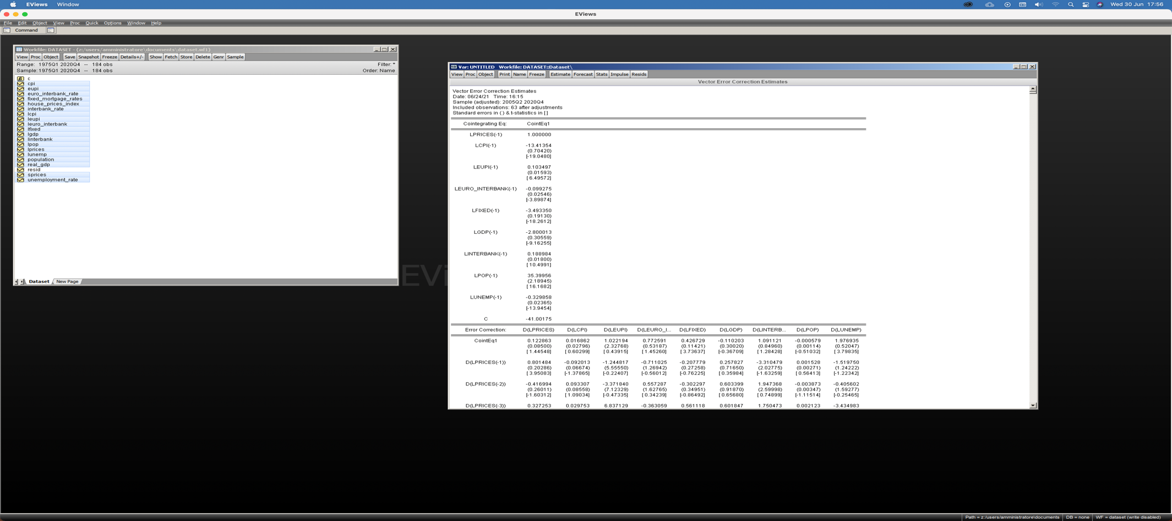

Tab.1 – Long Run Results

## **3.3 Model Results**

As per the results obtained from Cointegration Test we chose to use Vector Correction Model. From Johansen Test we found that the rank is 8 which implies that 8 cointegrating equations are present in the model. The equation for Vector Error Correction Model is as follows -

$$x_{t}= φ_{1}x_{t-1}+⋯⋯⋯⋯⋯⋯+φ_{p}x_{t-p}+ε_{t}$$

$$∆x_{t}= πx_{t-1}+ \sum_{i=1}^{p-1}{φ_{i}^{*}}∆x_{t-1}+ ε_{t}$$

where $π$ and $φ_{i}^{*}$ the are functions of the $φ$. Specifically,

$φ_{j}^{*}=$ $-\sum_{i=j+1}^{p}{φ_{i}}$, j= 1……,p-1

$$π= -\left(I-φ_{1}- ⋯⋯- φ_{p} \right)= - φ(1)$$

where $π$ is the rank of cointegration. If it is 0 then there is no cointegration.

For the sake of interpretability, we performed the VECM with 1 cointegrated equation. Through Johansen Normalization Restriction, we can infer the long run relationship between the independent variables and the home price index. The most unexpected results from our model were that GDP was not significant as well as the CPI, the Fixed Mortgage Rate and the Population. All the other variables were significant. In particular, the interbank rate and the euro interbank rate affects positively the home prices in the long run.

## **3.4 Impulse Response Function**

Impulse Response Function shed further light on the information revealed by Granger Causality results. It is useful for being able to explain the sign of the relationship as well as how long these effects require to take place. It can show how responsive a dependent variable is to a shock in an independent variable.

Whereas IRFs from a stationary VAR die out over time, IRFs from a cointegrating VECM do not always die out. Because each variable in a stationary VAR has a time invariant mean and finite, time-invariant variance, the effect of a shock to any one of these variables must die out so that the variable can revert to its mean. We need to be extremely careful when interpreting and analysing IRFs when used with a VECM.

We need to ensure that we demonstrate that IRFs are most appropriate for VAR models, but that IRFs are useful for gaining an insight into the sign of the relationship (positive or negative). We understand that effect of shock in a VECM is permanent rather than transitory.

From the below graph we find out that House Prices has positive relationship with Euro Interbank Rate, Interbank Rate and initially there was a permanent effect of the shock to the House Prices due to EUPI, CPI, GDP and later it became transitory. There is positive relationship between the House Prices with Fixed Mortgage Rate, Population, Unemployment however the effect of Population and Unemployment rate shows a negative impact on House Prices in the later stage.

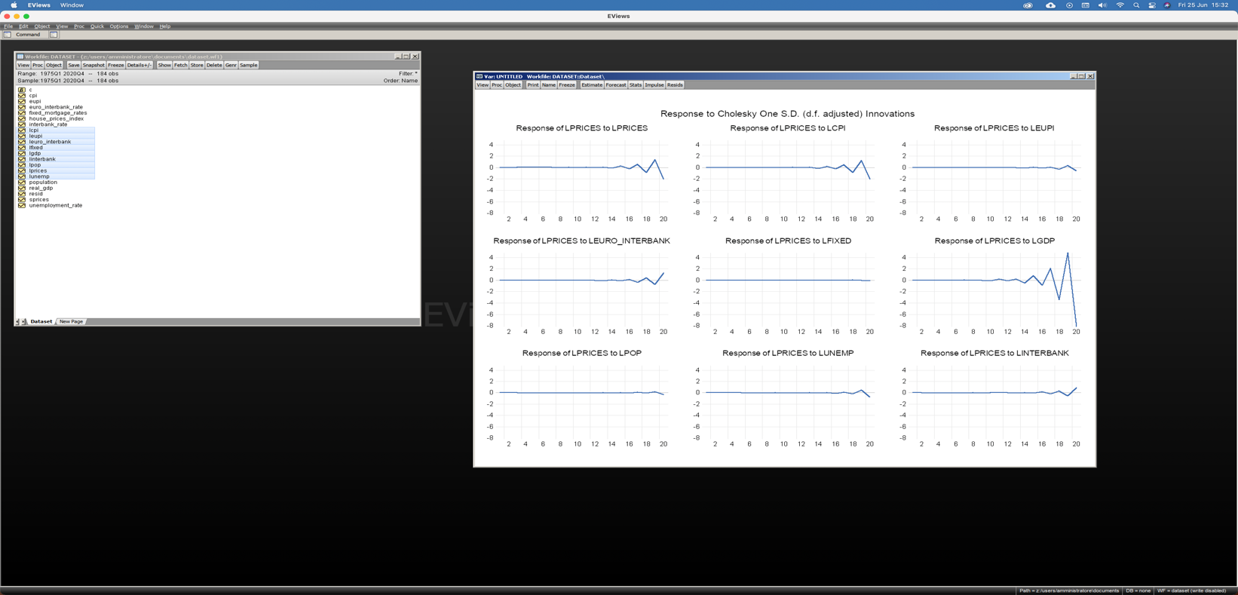

G3. IRF of House Prices to Monetary Shocks

# **Chapter 4 – Considerations and Implications**

In this section, we will tackle the two main reasons behind this research: How does Monetary Policy impact Housing Market and How does Monetary Policy respond to economic shocks? While we investigated only the first aspect, here we explain why interest rate should be a fundamental aspect in future studies.

**4.1 Brexit**

On June 23, 2016, the UK decided via referendum to leave the EU. The economic and institutional  
consequences of this decision for both the UK and the EU are still to come and they are surrounded by great uncertainty. These are for sure challenging times to policy makers, who must negotiate the term and conditions. The outcome of bilateral negotiations and how they will in practice be implemented will be key to assess the impact of Brexit.

In the UK, the Parliament has given the Financial Policy Committee at the Bank of England responsibility for “the identification, monitoring, and taking of action to remove or reduce systemic risks with a view to protecting and enhancing the resilience of the UK financial system.”

4.2 Covid-19

Brexit and Coronavirus are two different types of economic shocks which are affecting the entire UK economy simultaneously. Most of the economy will be hit by one or the other (or both). These shocks have provoked some of the steepest GDP declines ever in the UK.

## 

## **4.3 Monetary Policies**

The Bank of England’s Monetary Policy Committee (MPC) sets monetary policy to keep inflation low and stable, which supports growth and jobs. The Monetary Policy Committee currently uses two main monetary policy tools.

1. Bank Rate - Set the interest rate that bank and building societies earn on deposits or reserves, placed with the Bank of England
2. Quantitative Easing or Asset Purchase- Buying government & Cooperate Bonds, financed by issuance of central bank reserves

**How does UK Monetary Policy respond to Brexit & Covid shock?**

From the literature review we found that in response to Covid pandemic, MPC have taken prompt and substantial action to help household & businesses. MPC have taken following steps -

1. They have cut interest rate to 0.1% in March 2020 and kept them at the same level.
2. They had allowed UK banks and building societies to borrow cheaply from them so they can reduce the rates which they charge their customers
3. Quantitative Easing, which helps to keep the interest rates on mortgages and business loans as low.

From the website of Bank of England, we found an interesting graph which depicts how MPC have cut interest rate due to covid.

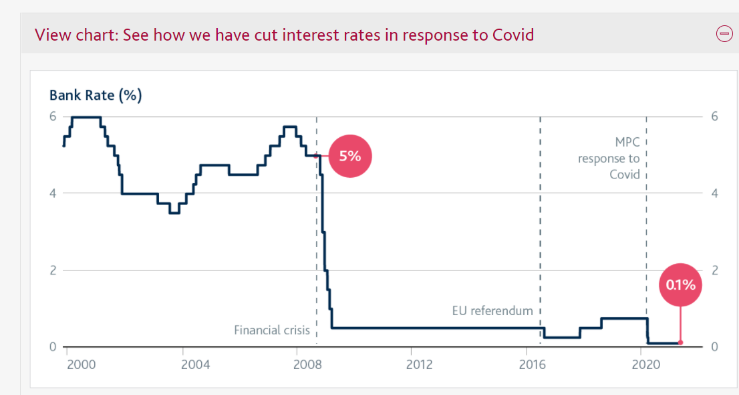

Lower the interest rate implies cheaper loans for businesses and household. It will help in reducing the cost they face and encourages companies to employ people and invest.

Our analysis & the standard economic theory tells us that monetary policy should affect house prices and housing finance more generally. Using Ceteris Paribus (all else equal) higher interest rates increase the cost of owning a house, which implies a lower asset value.

When anticipating the future price movements in the housing market it is essential to have the best possible forecast of demand and the demand for housing market is most importantly determined by incomes and unemployment rate.

There were some specific measures which were taken by UK Government supporting activity in the housing market and house prices and the position of renters. The scheme getting most attention has been SDLT holiday. This started in July 2020 and was originally due to end on 31 March 2021 but in the March Budget, it is extended to June 30, 2021. It is worth upto £15,000 on £500,000 houses, with bigger discounts for more expensive houses upto the ceiling of £500,00. There were other measures too- aside from the extraordinarily low interest rates such as potential mortgage payment holidays for 6 months to those who had lost income due to Covid-19. Another scheme was launched in the March 2021 budget, it is for first time buyers with deposit of only 5% instead of the 20% normal since the financial crisis. There was also some help for tenants with a stop on evictions except in the most extreme circumstances.

One another consideration is that the effects of the Covid-19 crisis are in context of absorbing the impacts of Brexit. The conclusion from the earlier research show that Brexit will lead to slower economic growth and lower incomes. Hence there is a reason to think that Brexit may affect UK Housing Market.

When firms and households make decisions about investment and spending, they take the future into account. Their central expectations about the economic outlook — what they think is most likely to happen — are important. Uncertainty around those expectations also affects decisions being made now

# **Chapter 5 – Limitations & Conclusions**

In this section, we will state our model limitations, our suggestions for future studies and reflections on possible presumptions from a policy maker perspective.

## **5.1 Limitations of our study & Recommendations for future Research**

The main limitations of our study are two: 1) The construction of the average of car and light trucks price variable and 2) the magnitude of our model. We were able to gather data only for annual average prices of car and light trucks. In order to proceed with our research, we made the strong assumption that monthly average auto prices would be equal to Annual Average divided by No. of Months. The fundamental difficulty in deriving a price variable for the model is that "the actual sales price or transactions price" between the auto dealer and the consumer is an unknown figure. While actual sales prices exist in the files of state revenue offices, the costs of extracting this information make it virtually inaccessible. We would recommend building a price function in order to correctly estimate the monthly average auto prices.

An ideal Demand function would include a series of variables that need to be calculated that we omitted. For example, used car and automobile stock variables are needed to capture the alternatives for the consumers. In addition, a dummy for the ownership of a vehicle would help to estimate the choice of delaying the purchase of a new car. We performed a rudimental analysis considering the general landscape of the auto market in U.S; an improved version should divide the sales into brands and category of vehicles at the state level. Moreover, one can consider also categorical variables such as colour and size. Another strong limitation of our model was the use of indexes instead of actual values; ideally, functions to capture the trends in those variables should be created. The best method to do so is to conduct surveys. Lastly, to be more accurate, discretionary income, which is the money that an individual or a family has to invest, save, or spend after taxes and necessities are paid, would be a better variable to predict the sales trend.

## **5.2 Conclusions**

The aim of this paper is to create a model for the demand of new cars in the automotive market in the US and to lay the foundation for future studies.

The analysis conducted investigated the relationship between the new auto sales and a set of explanatory variables such as the income of consumers, the gasoline price, and the prices of public transportation and insurance. The developed model respects the Law of Demand and Supply, since the findings suggest that the increase in prices reduce total sales of cars while the rise in income fosters total sales. The achieved results regarding the demand meet the expectations, however, the price elasticities in the short and in the long run are opposite to what past studies predicted.

Besides having studied in depth the descripted relationship, this analysis allowed us to make inferences regarding the market landscape. In particular, we considered potential reasons behind the increase in car prices, the role of loans and interest rates as a mean used by the families to be able to afford new cars as well as a differentiated source of profit for car manufacturers, and possible policy concerns of the government related to the environment.

In conclusion, the study of the automobile demand is fundamental in order to raise policy makers awareness in the issue of new regulations. In fact, they could not only jeopardize the efficiency of other regulations, but also trigger phenomena potentially dangerous for one of the biggest industries in the world which is the automotive as well as for the whole economy.

# **Appendix**

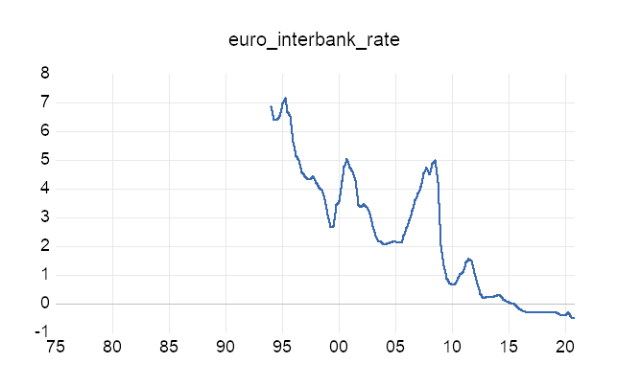

Figure 1. Euro Interbank Rate Trend

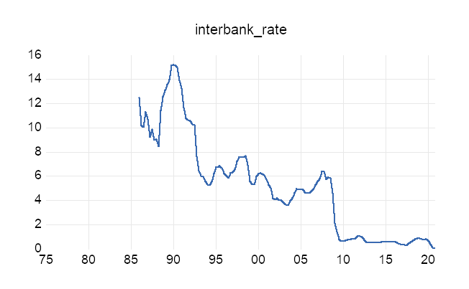

Figure 2 Interbank Rate Trend

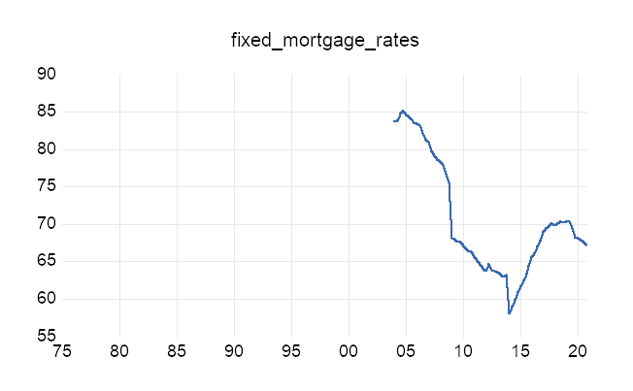

Figure 3 Fixed Mortgage Rate Trend

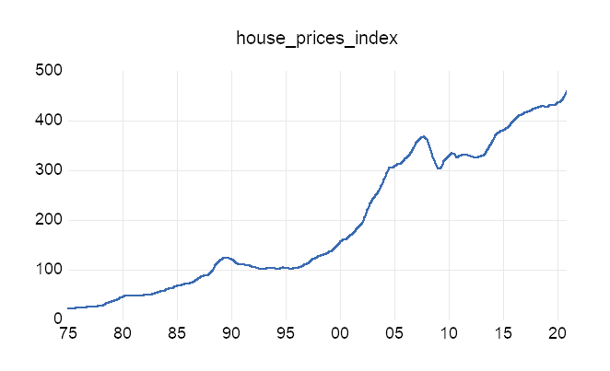

Figure 4 House Price Index Trend

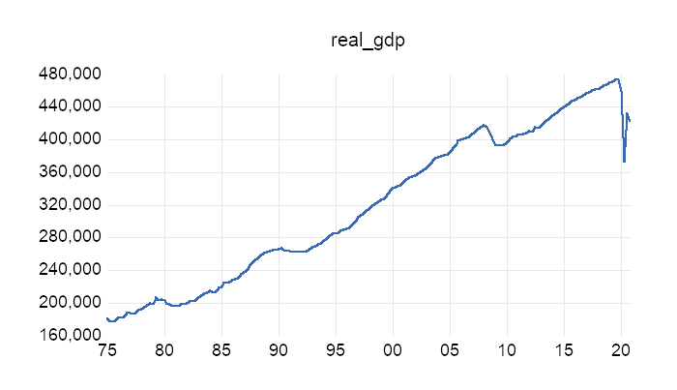

Figure 5 Real GDP Trend

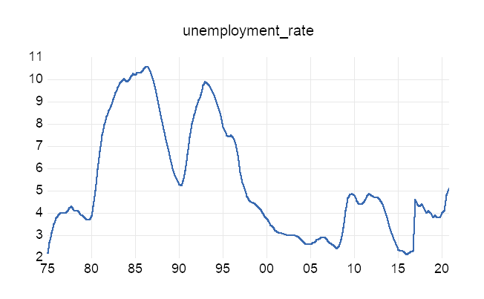

Figure 6 Unemployment Rate Trend

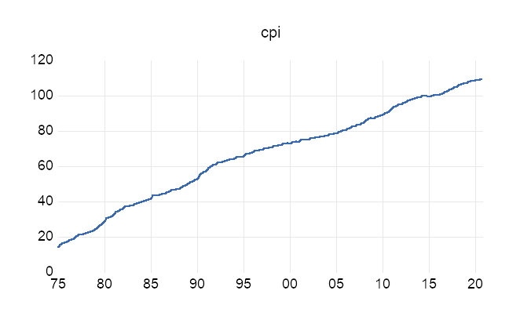

Figure 7 Consumer Price Index Trend

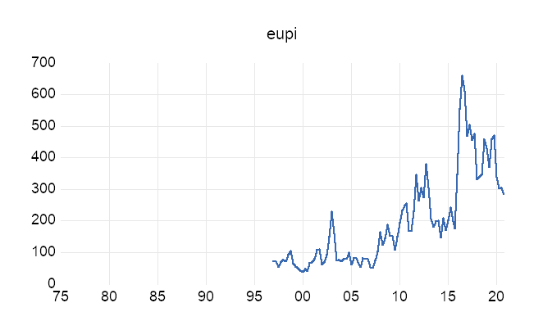

Figure 8 Economic Policy Uncertainty Trend

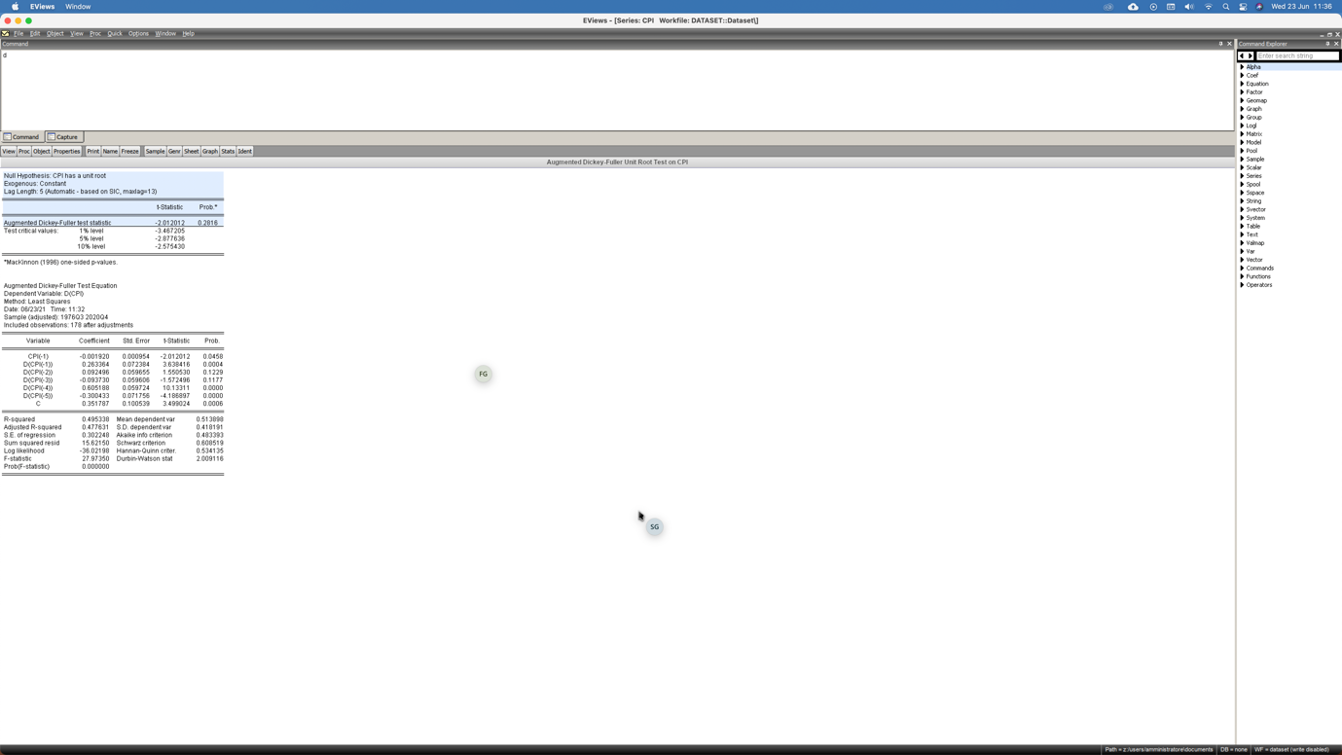

Figure 9 CPI Unit Root

**

Figure 10 EUPI Unite Root

**

Figure 11 EURO Interbank Rate Unit Root

**

Figure 12 Fixed Mortgage Rate Unit Root

**

Figure 13 House Prince Index Unit Root

**

Figure 14 Interbank Rate Unit Root

**

Figure 15 Real GDP Unit Root

**

Figure 16 Unemployment Rate Unit Root

# 

Figure 17 1st Difference HPI Unit Root

**

Figure 18 1st Difference GDP Unit Root

**

Figure 19 1st Difference Interbank Rate Unit Root

**

Figure 20 1st Difference Fixed Mortgage Unit Root

**

Figure 21 1st Difference Euro Interbank Unit Root

**

Figure 22 1st Difference EUPI Unit Root

**

Figure 23 1st Difference CPI Unit Root

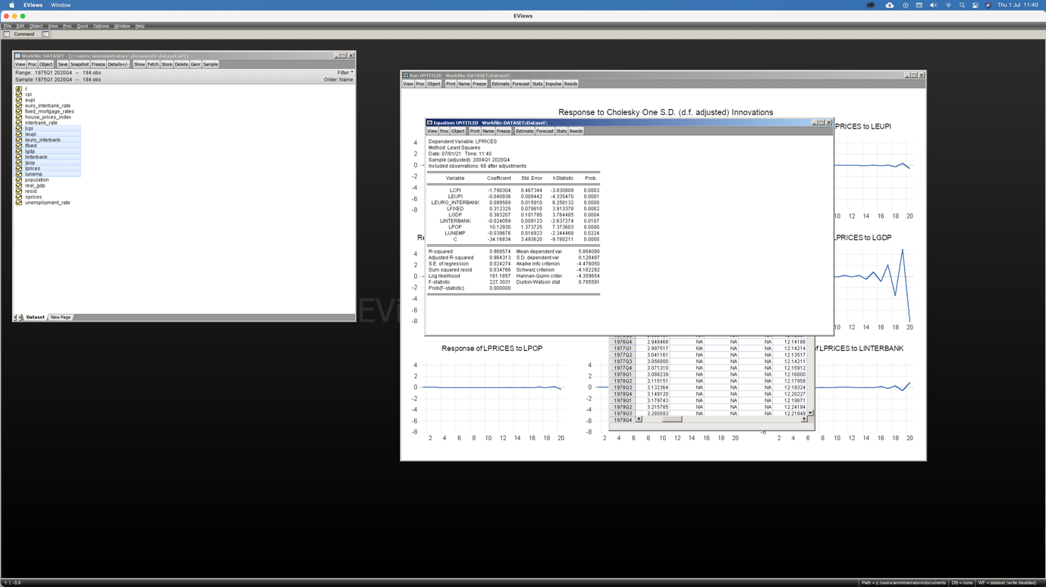

Figure 24 OLS Output Results

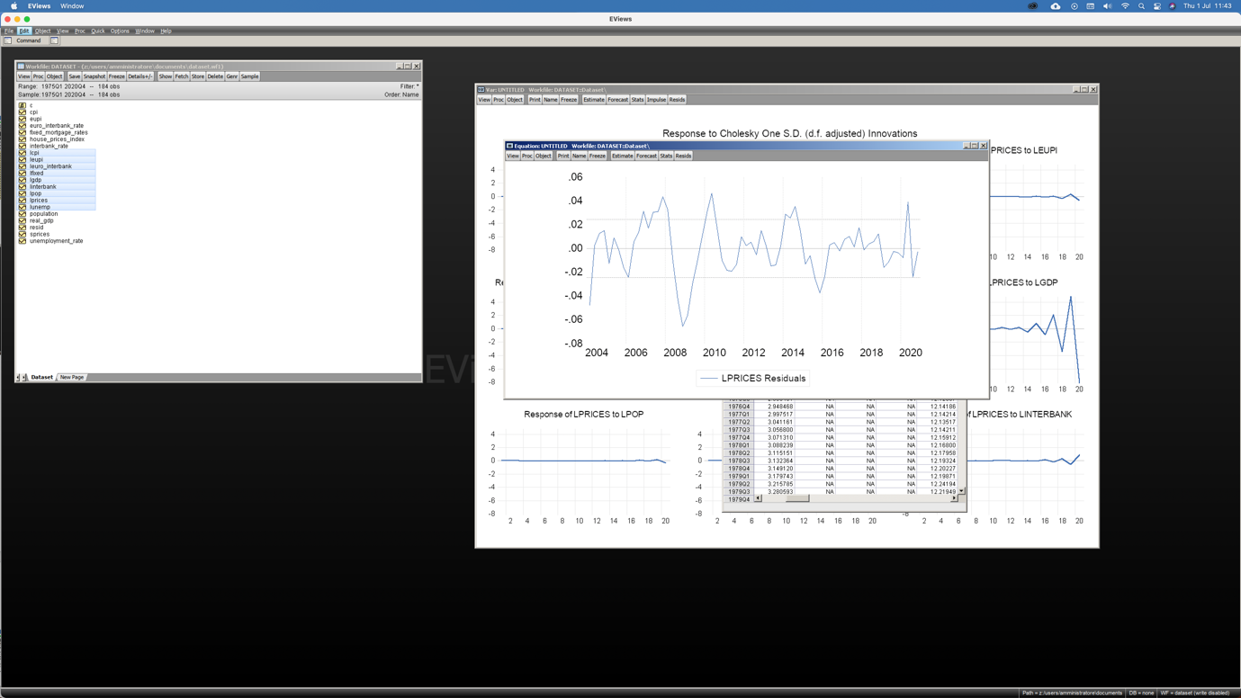

Figure 25 OLS Residuals

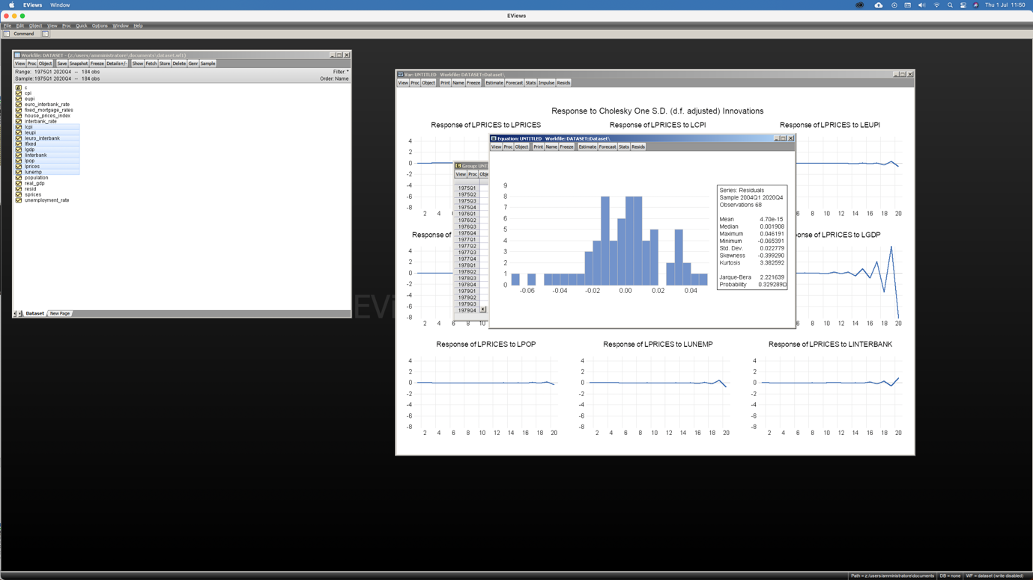

Figure 26 Residual Distribution

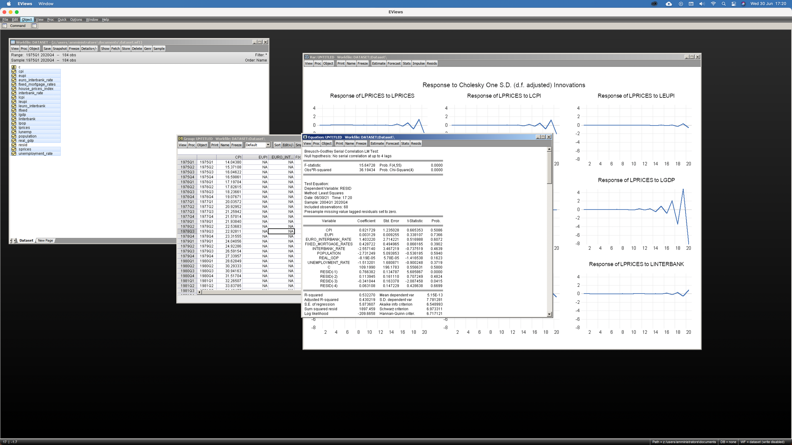

Figure 27 OLS Autocorrelation

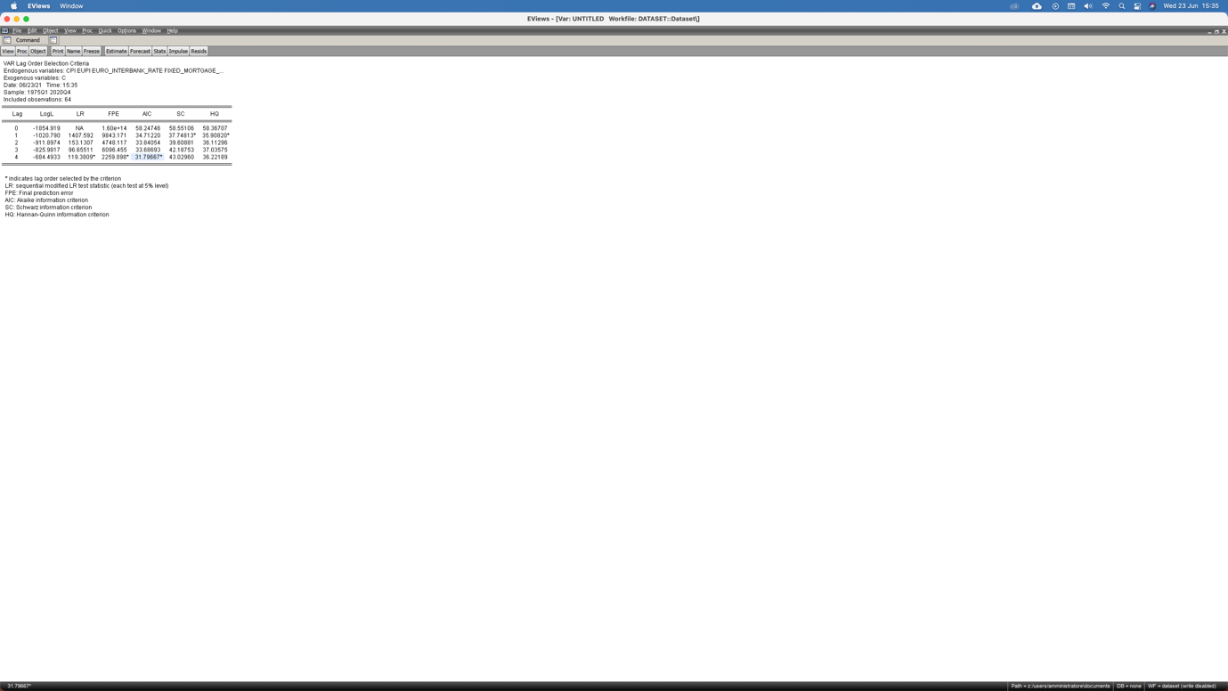

Figure 28 Lag Selection

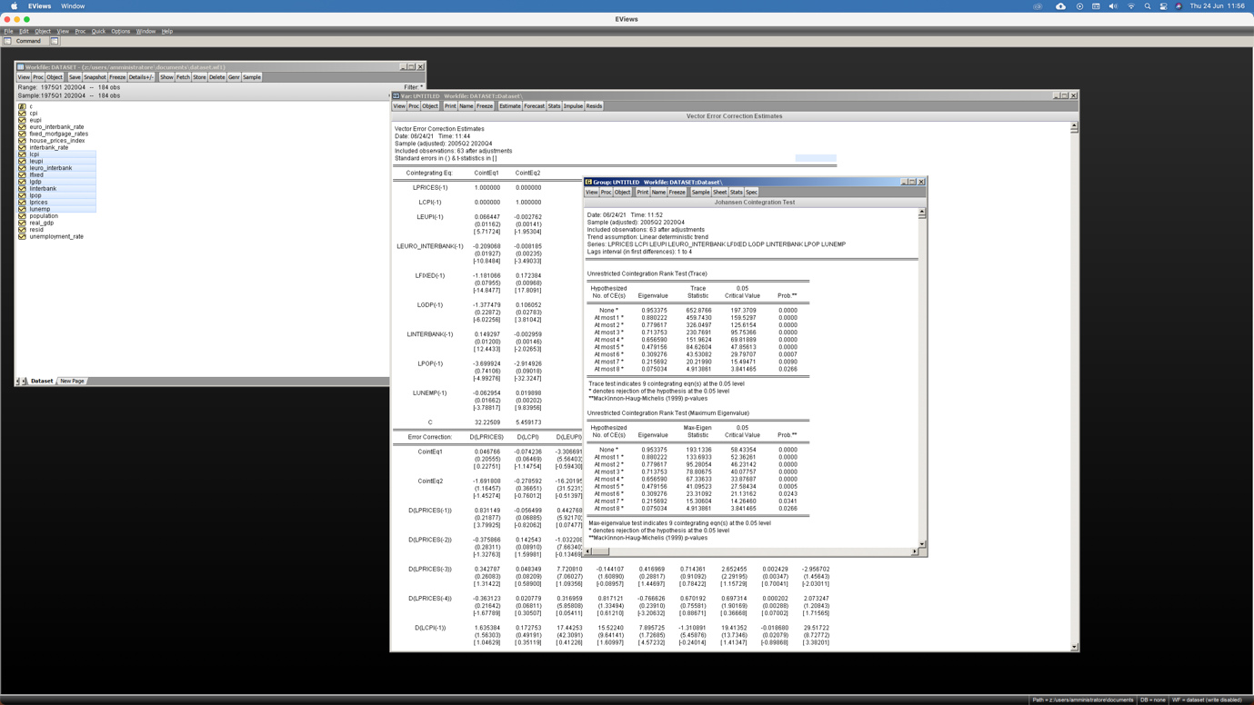

Figure 29 Unrestricted Cointegration Rank

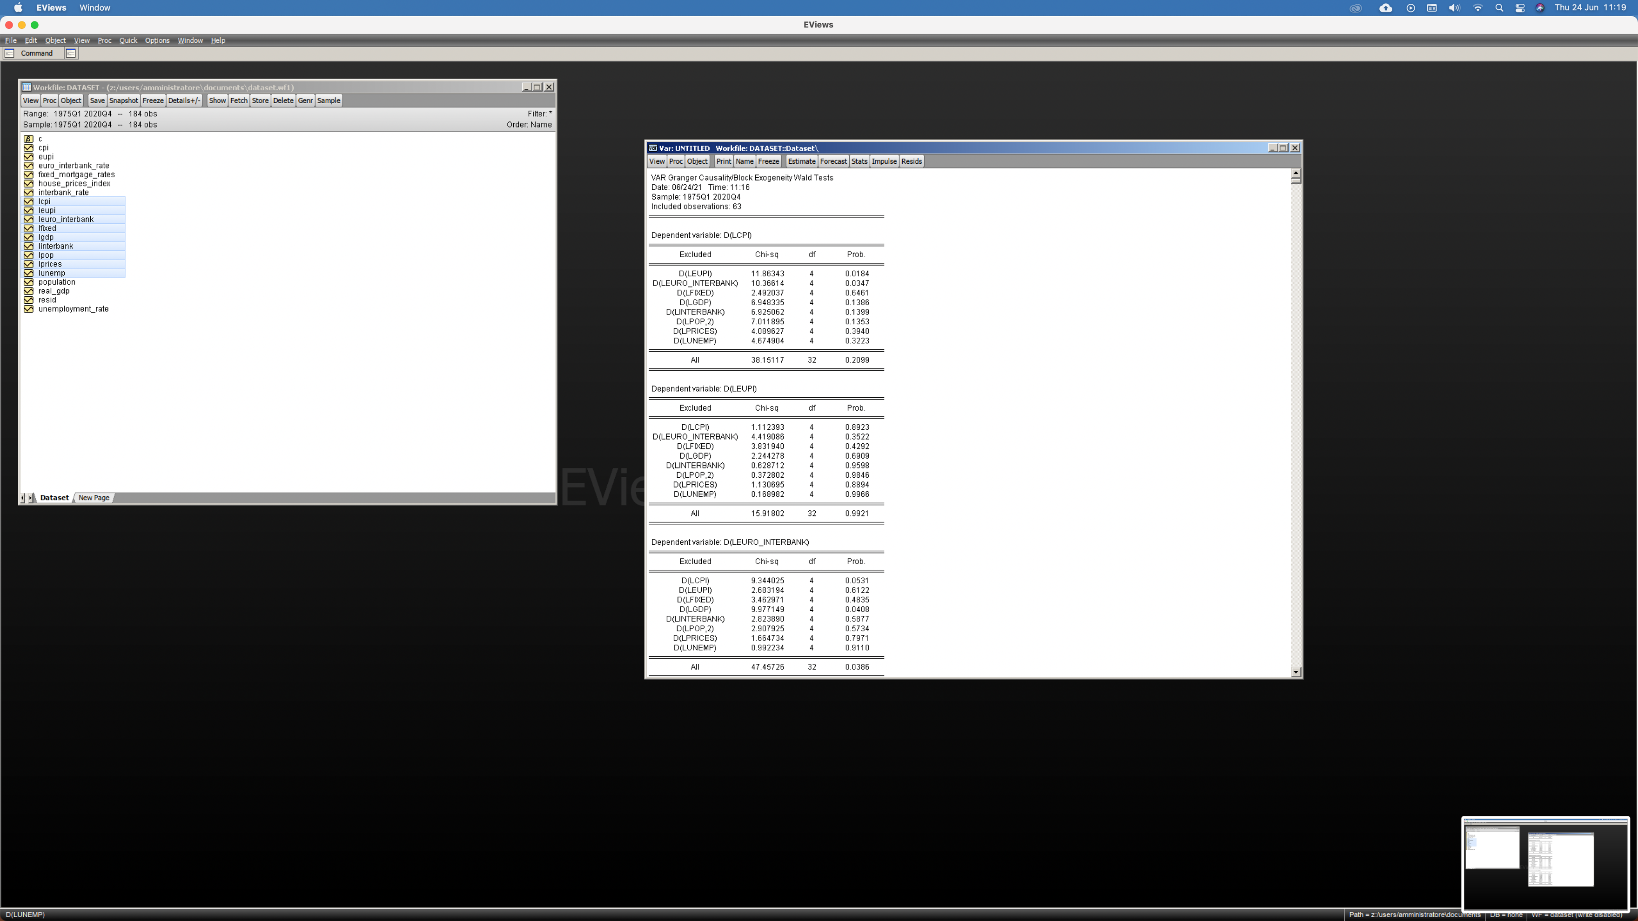

Figure 30 Granger Causality

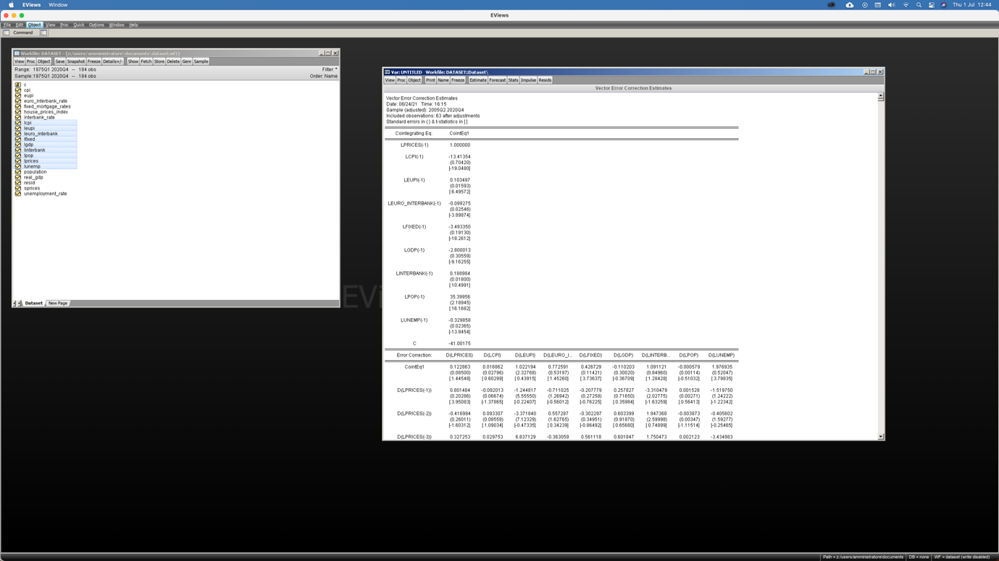

Figure 31 VECM

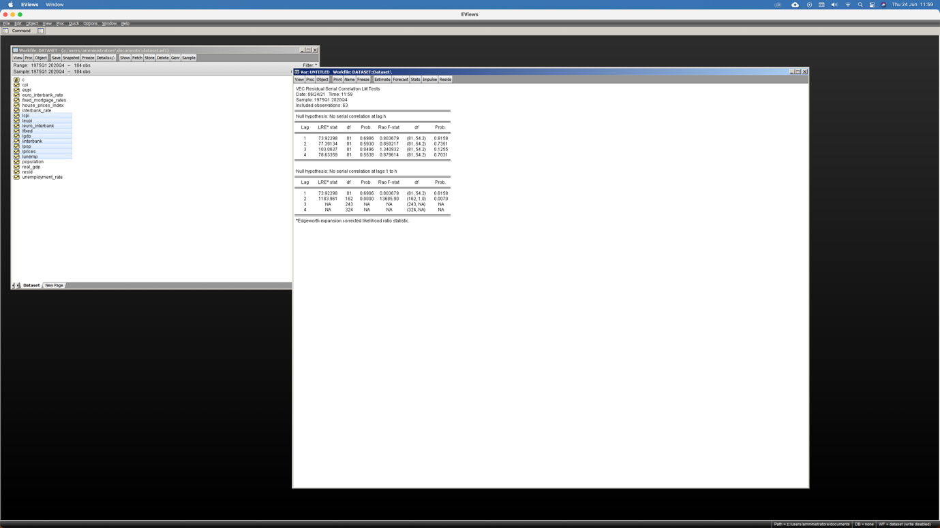

Figure VECM Serial Correlation Test

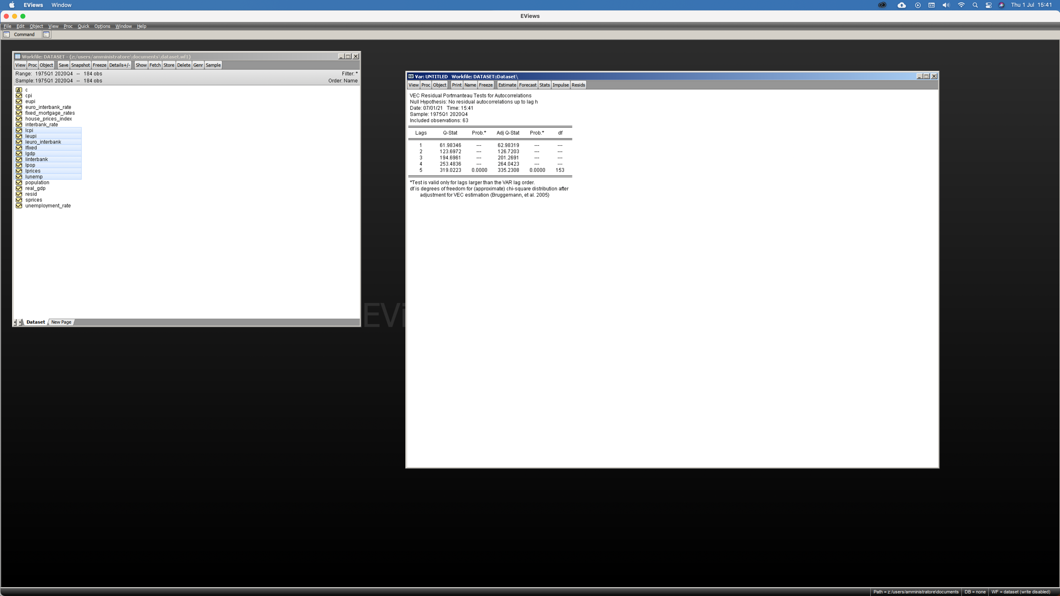

Figure 33 VEC Autocorrelation Test

**

Figure 34 VEC Normality Test

# **References**

1. Federal Reserve Bank of St. Louis <https://fred.stlouisfed.org/>
2. Economic Policy Uncertainty <https://www.policyuncertainty.com/methodology.html>
3. Nationwide <https://www.nationwide.co.uk>
4. Bank of England <https://www.bankofengland.co.uk>
5. Monetary policy shocks and industrial output in BRICS countries http://hdl.handle.net/10419/169181
6. House Prices, Money, Credit and the Macroeconomy http://www.ecb.europa.eu